**User Guide**

**Table of Contents:**

**System Overview**

*Users*

*System Structure*

*Interface Design*

**Production Process**

*Summary*

*Production Documentation*

*Use Case*

**Return Process**

*Summary*

*Return Documentation*

*Use Case*

**System Overview**

Users:

Production Manager - The PM needs to use the system to update inventory in real time, check on the production of rods and lures, and produce daily reports.

Quality Manager - The QM needs to use the system to check production and incoming goods for quality control. The QM also needs to be able to review information about returns in order to assess where quality broke down.

Accounts Clerk - The Accounts Clerk needs to use the system to review Return forms and issue refunds or replacements.

Customer - The customer needs to use the system to obtain an authorization code and fill out Return forms to be submitted for review.

System Structure:

Login Page - The users will login with their user ID and password.

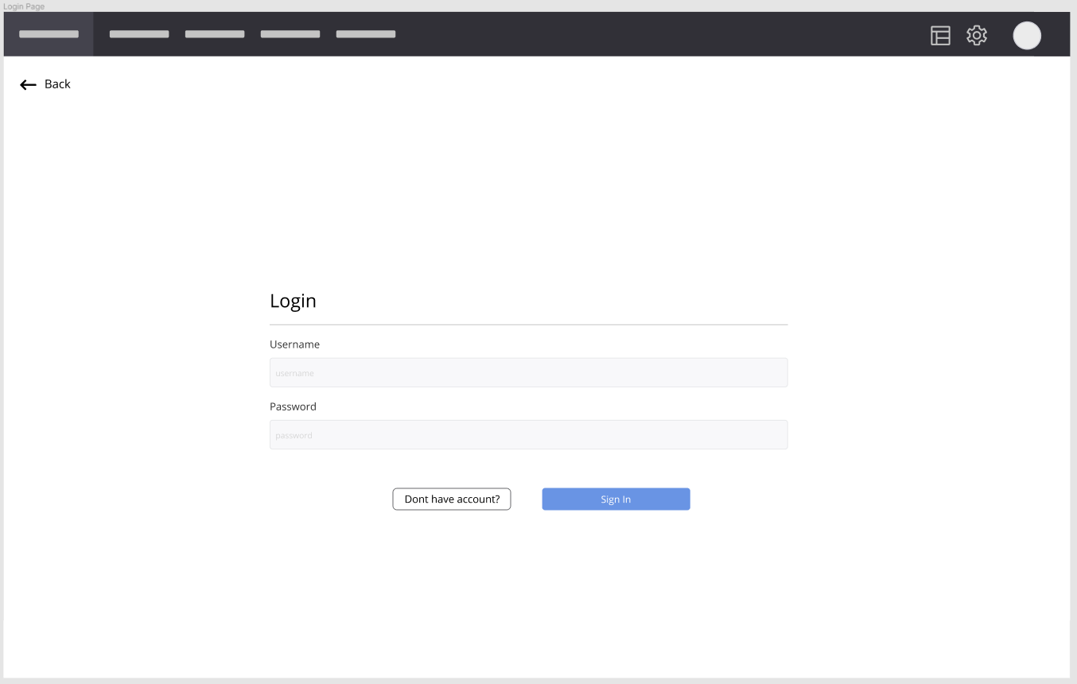

Home Page - This is the main page with links to all the other pages.

Production Page - This page has links to an Orders page to check on outstanding and fulfilled orders, as well as a Quality Control page to see which batch IDs need to be checked further.

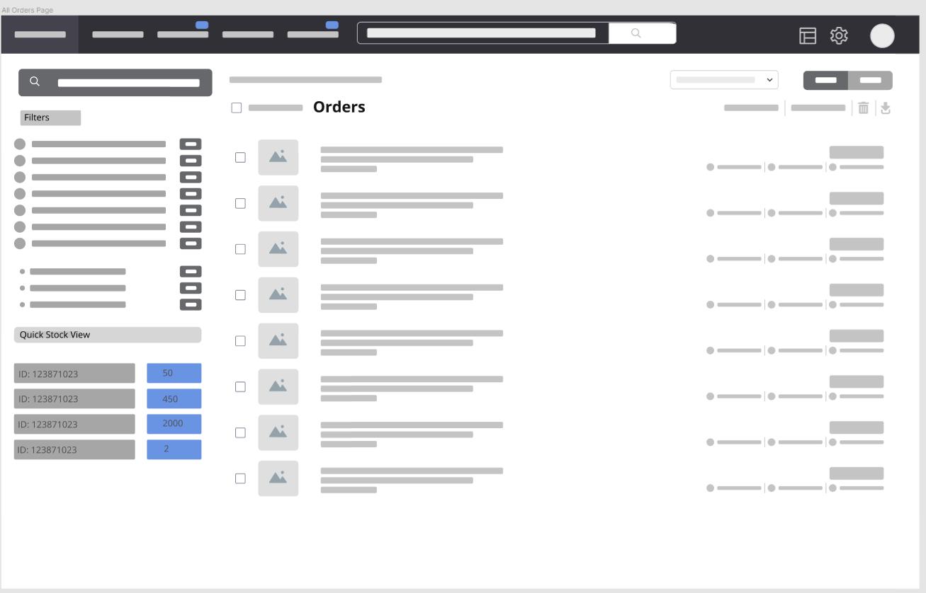

Order Page - (*Incoming orders not customer ordering portal*)

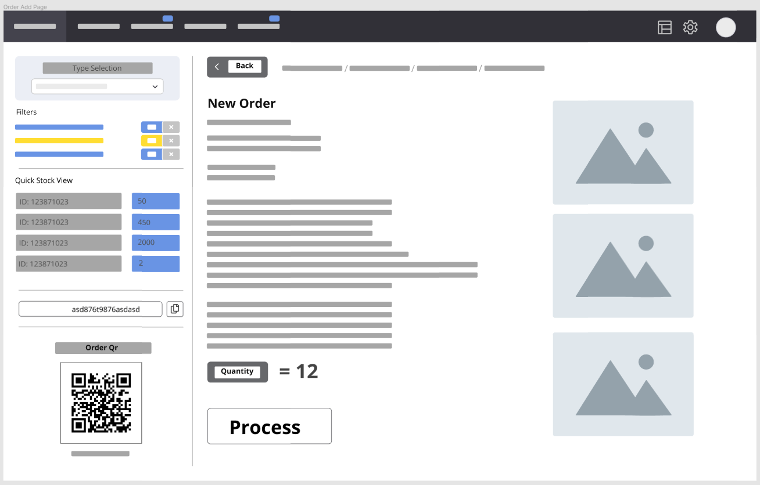

Inventory Page - This page allows for manual updating of the inventory as well as the ability to generate inventory reports.

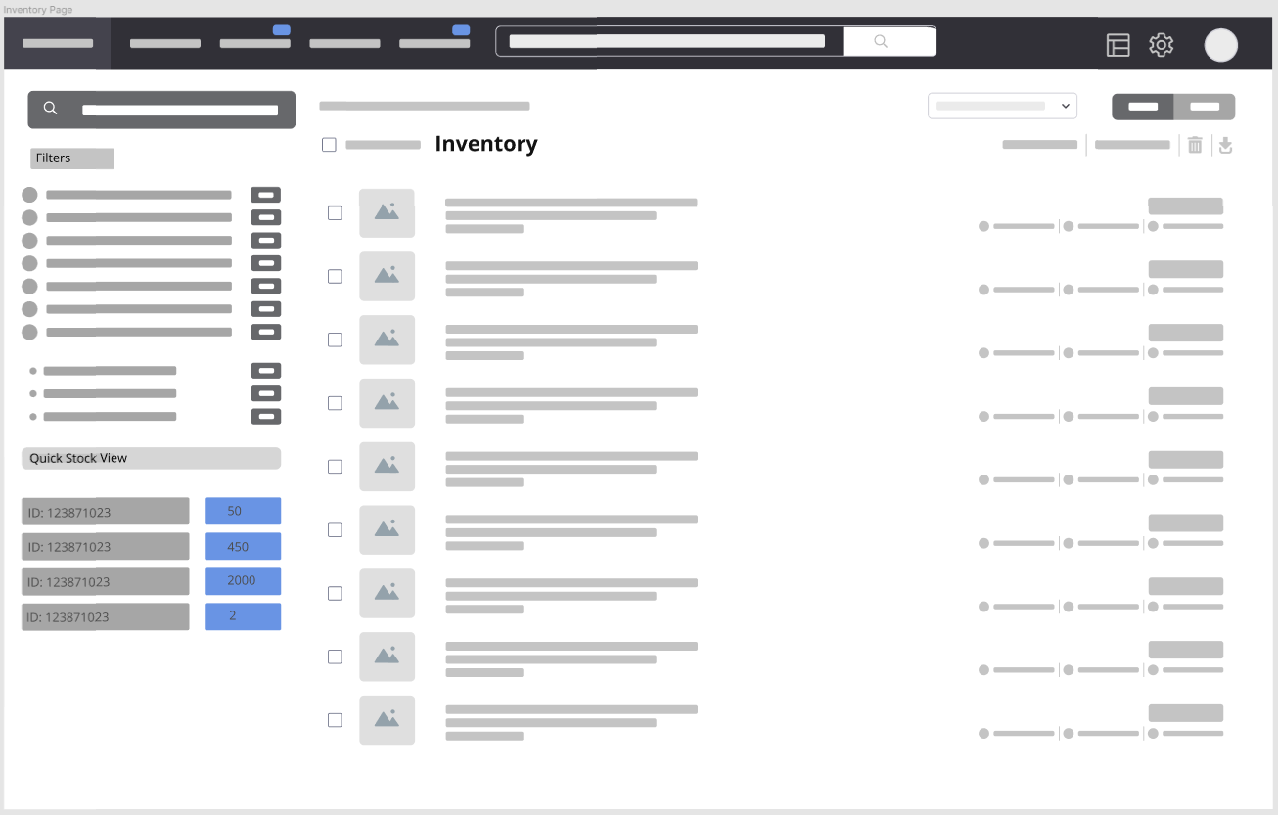

Inventory Item Page - The Inventory page has a list of the current Inventory. There is a filter option for sorting the inventory. There is also a Quick View of the available stock and the quantity of each.

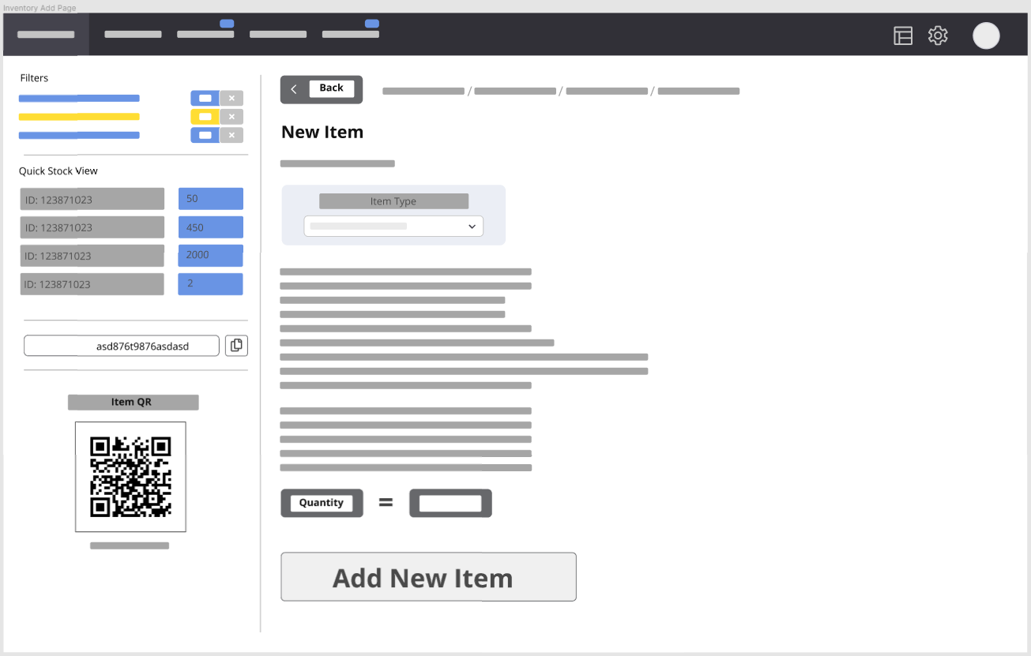

Quality Page - This page is used to keep informed about the quality issues that are reported by the system.

Returns Page - This page is used to process returns and can be used to look up and input both return requests and customer information.

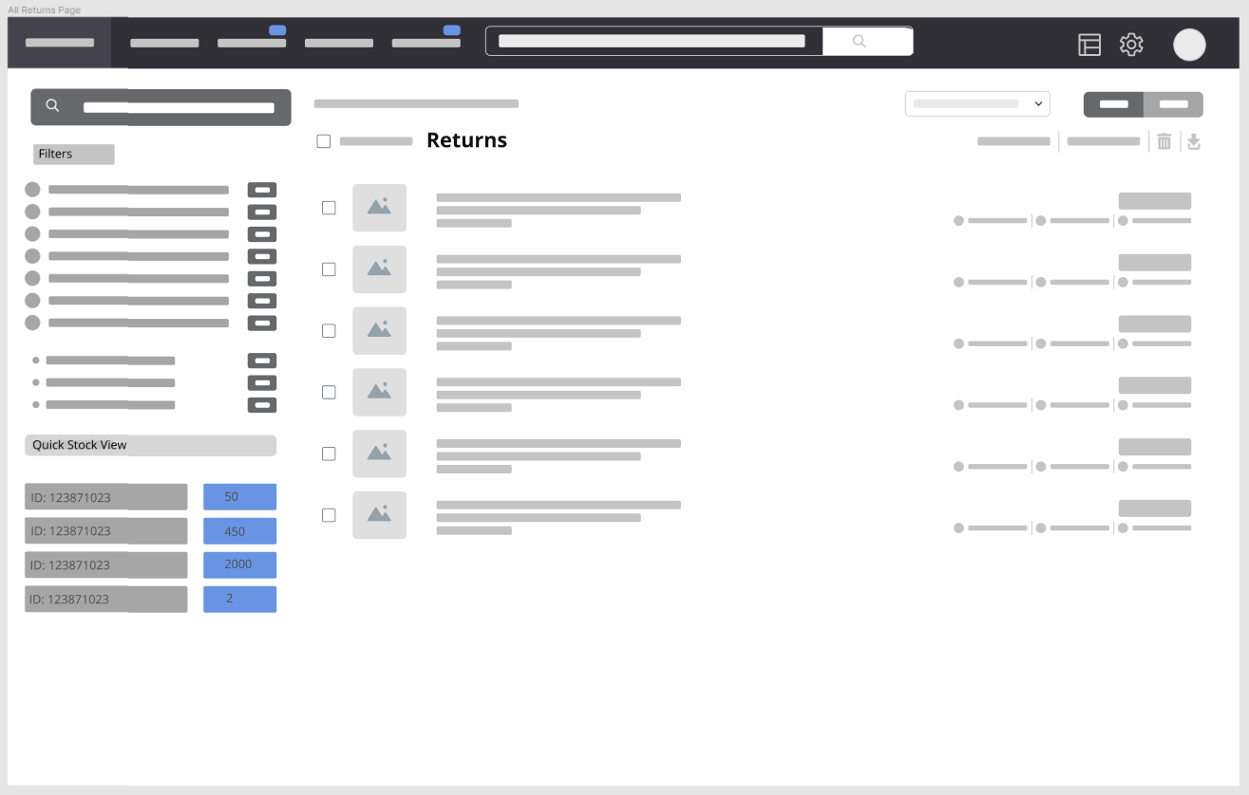

Return Page - This page is used to process returns for an individual return. You are able to see all the data about the return along with identification.

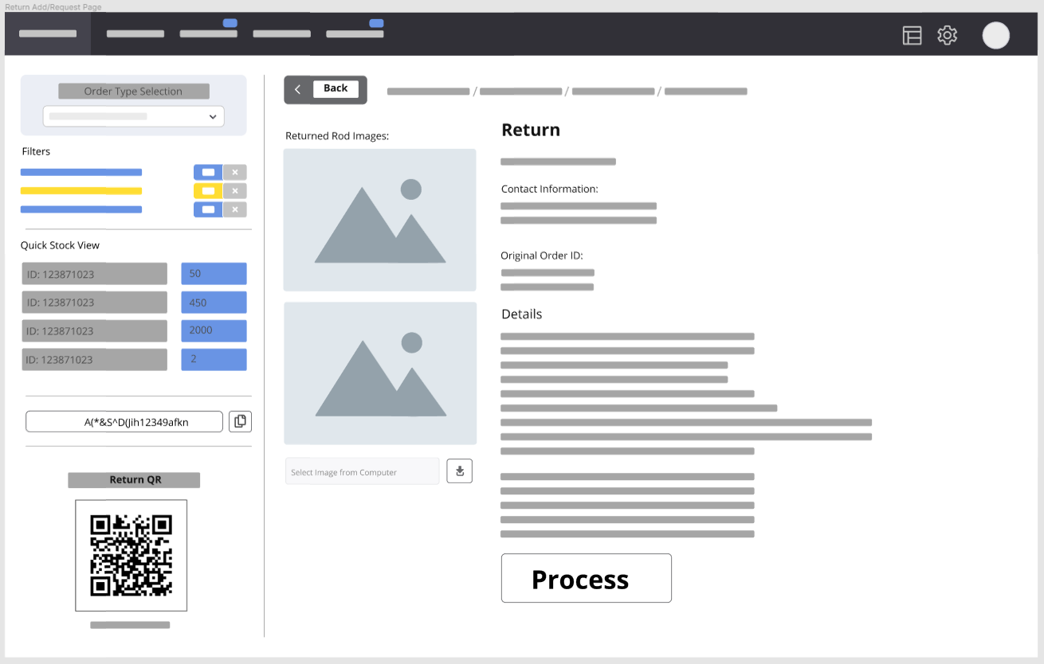

Interface Design: (web browser)

**Production Process**

Summary:

Production Documentation:

Use Case:

The production order is received.

Rods are produced and stamped with a batch id.

Quality Control inspects the rods.

The system updates the inventory.

**Return Process**

Summary:

Return Documentation:

Return Data -

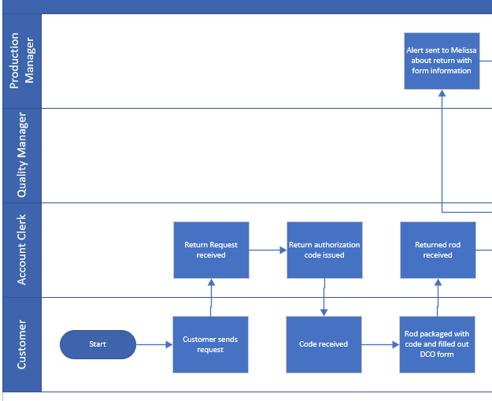

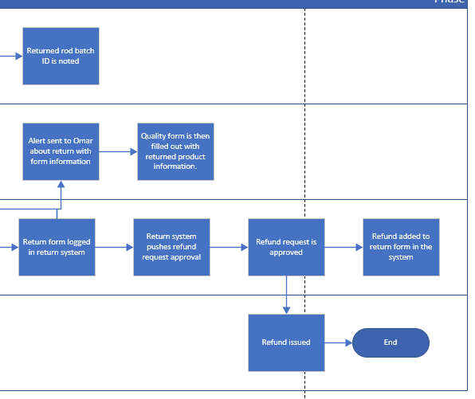

Refund Data -

Return Form -

Use Case:

The Account Clerk inputs a Return Request.

The system issues an authorization code.

The Customer receives the code and returns the merchandise with the code and filled out Return Form.

The Account Clerk logs the return into the system.

The system alerts QM and PM about the return.

The system issues a refund.